Student Performance Prediction: An Exploratory Data

Analysis Approach
Project submitted to the

APSSDC

Bachelor of Technology In
COMPUTER SCIENCE ENGINEERING
Rajeev Gandhi Memorial College of Engineering and Technology

Submitted By

Kotha Reddy Venkata Javahar Reddy



Under the guidance of K.Narmada Mani
K. Vanitha

June 2025

TABLE OF CONTENTS

S.No | Content | Page.no
1 | ABSTRACT | 3
2 | INTRODUCTION | 5
3 | SYSTEM REQUIREMENTS | 6
4 | ARCHITECTURE | 7
5 | PROJECT CODE AND SCREENSHOTS | 9
6 | USES OF DATA ANALYSIS LIBRARIES | 18
7 | ADVANTAGES | 19
8 | CONCLUSION | 21
9 | REFERENCES | 22

ABSTRACT

This study presents an in-depth analysis of student performance sales data using Python's powerful data manipulation library, Pandas, and the versatile data visualization library, Matplotlib.
The dataset used in this analysis comprises a comprehensive collection of sales records for 1,000 student performance products, encompassing various attributes such as product categories, monthly sales data across a 12-month period, pricing information, and customer review scores.

The primary objectives of this analysis are as follows:
Explore Sales Patterns: We start by examining sales patterns over time, identifying trends, seasonal variations, and potential spikes in purchasing activity that could indicate high-demand periods, promotional impacts, or holiday-driven surges.
Product Segmentation: By leveraging Pandas' data filtering capabilities, we perform segmentation based on product categories, pricing tiers, and review ratings—providing insights into the platform’s top-performing products and most influential customer segments.
Review Score Impact: We delve into customer review scores, studying their distribution and analyzing how product ratings correlate with sales volume and customer trust, revealing their potential impact on product visibility and success.
Pricing Influence: Analyzing product pricing and corresponding sales performance allows us to understand pricing elasticity, detect optimal pricing zones, and identify products that may benefit from price adjustments.
Geographic Insights: If location-based data is available, we visualize the geographic distribution of sales and evaluate how customer location influences purchasing behavior and product popularity.
Revenue Analysis: Using Pandas to calculate revenue metrics, we gain a clear understanding of financial performance across different months and product segments, helping identify revenue-driving categories and sales cycles.

Throughout the analysis, we employ Python’s Pandas library to clean, preprocess, and manipulate the data, ensuring accurate and meaningful results. We then visualize the findings using Matplotlib, creating clear and insightful plots, charts, and graphs that simplify the interpretation of complex data trends.
The study's outcomes contribute valuable insights to student performance business stakeholders, helping them make data-driven decisions to optimize pricing, inventory management, product listings, and marketing strategies. Additionally, the combination of Python, Matplotlib, and Pandas demonstrates a powerful toolkit for conducting scalable, insightful data analysis in the student performance domain, applicable to a wide range of online retail challenges.

INTRODUCTION
In today’s digital economy, the student performance industry has become one of the most dynamic and competitive sectors globally. With millions of transactions occurring daily across various platforms, student performance businesses accumulate vast amounts of data that, when properly analyzed, can offer deep insights into consumer behavior, sales performance, and market trends. However, raw data alone holds limited value unless it is transformed into meaningful information that can drive strategic decisions.
This project, titled “Uncovering Insights from Student Performance Prediction: An Exploratory Data Analysis Approach,” aims to bridge the gap between raw transactional data and actionable business insights. By leveraging Python’s data science libraries—Pandas for data manipulation and Matplotlib for visualization—we conduct a thorough Exploratory Data Analysis (EDA) on a dataset comprising 1,000 student performance products. The dataset includes key attributes such as product categories, prices, monthly sales data over a 12-month period, and customer review scores.
The goal of this analysis is to explore and interpret patterns that can inform decisions in areas such as marketing, pricing strategy, product assortment, and customer engagement. Through EDA, we identify top-performing product categories, assess the influence of pricing and customer reviews on sales, detect seasonal trends, and evaluate overall revenue performance.
This project demonstrates the critical role of data analysis in student performance operations. By turning raw sales data into actionable insights, businesses can make informed decisions to improve profitability, customer satisfaction, and market positioning. Additionally, this study showcases how open-source tools like Python and its libraries empower data-driven decision-making, making advanced analytics accessible even to small and medium-sized enterprises.

SYSTEM REQUIREMENTS

SOFTWARE REQUIREMENTS:
- OPERATING SYSTEM:
- Windows 10/11 or Linux (Ubuntu 20.04+) or macOS

Python:
Python 3.x is required for running the analysis. Make sure you have the latest stable version of Python installed.
- Libraries: Pandas, NumPy, Matplotlib, Seaborn
- IDE: Jupyter Notebook or VS Code, Google Collaboratory

HARDWARE REQUIREMNTS:
- Storage Space – free storage space enough for running on machine
- Minimum 4 GB RAM
- 500 MB of available disk space

ARCHITECTURE
The architecture of this project is designed to follow a systematic data analysis pipeline, starting from data acquisition and ending with insight generation. The flow of the project can be broken down into the following stages:
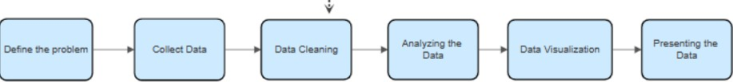

Data Collection
  - The analysis begins with obtaining the E-commerce dataset. Data can be collected from various sources, such as a ecommerce internal database, publicly available datasets, or through web scraping from booking platforms.
  - Once the data is acquired, it is typically stored in a structured format like CSV, Excel, or a database.
  - It contains attributes such as product ID, category, monthly sales, price, and customer review scores.

Data Preprocessing
  - Using Pandas, the data is loaded, cleaned, and prepared for analysis.
  - Steps include:
    - Handling missing values
    - Correcting data types
    - Removing duplicates
    - Generating new columns (e.g., total annual sales, revenue)

Exploratory Data Analysis (EDA)
  - Key questions are defined (e.g., What are the top-selling categories? How do reviews impact sales?).
  - The data is grouped, aggregated, and filtered using Pandas functions.

Data Visualization
  - Visual insights are generated using Matplotlib and Seaborn.
  - Common charts used include:
    - Bar plots (e.g., sales by category)
    - Line plots (e.g., monthly sales trends)
    - Scatter plots (e.g., price vs. sales, review score vs. sales)
    - Heatmaps (e.g., sales correlation matrix)

Insight Extraction
  - Insights are drawn from the visualizations and summary statistics.
  - Examples:
    - Identifying high-performing products
    - Recognizing seasonal sales trends
    - Understanding the relationship between price and customer reviews with sales

The ecommerce data analysis project, built using Python along with tools such as Pandas and Matplotlib, follows a structured workflow that seamlessly integrates data acquisition, preprocessing, exploratory data analysis, and visualization. This organized approach ensures that raw transactional data is transformed into valuable business intelligence, enabling companies to make informed decisions that drive growth, improve customer satisfaction, and support long-term strategic planning.

PROJECT CODE AND SCREENSHOTS

Importing Required Libraries
import pandas as pd
import matplotlib.pyplot as plt import seaborn as sns
pd.options.mode.chained_assignment=None

Explanation:
This section imports the essential Python libraries used for data analysis and visualization in the project:
  - pandas as pd: Imports the Pandas library, which is used for data manipulation and analysis. It helps in reading the dataset, cleaning data, filtering, grouping, and computing various statistics.
  - matplotlib.pyplot as plt: Imports the plotting module from Matplotlib, which is used to create static, animated, and interactive visualizations like bar charts, line graphs, etc.
  - seaborn as sns: Imports the Seaborn library, which is built on top of Matplotlib and provides enhanced, attractive, and informative statistical graphics.
  - pd.options.mode.chained_assignment=None: This line is used to suppress warnings related to chained assignments in Pandas. It's a safety measure to avoid unnecessary warning messages when modifying data in subsets of DataFrames.

Loading the Dataset
sp= pd.read_csv("student_perfromance_prediction.csv", encoding="unicode_escape")
data

Explanation:
This code reads the student performance sales data from a CSV file into a DataFrame named data using Pandas. The encoding="unicode_escape" handles any special characters in the file. Displaying data shows the first few rows of the dataset for quick inspection.

- Previewing the Dataset sp.head(5)
- sp.sample(5)
sp.info()

Explanation:
  - sp.head(5): Displays the first 5 rows of the dataset to give an initial view of the structure and content.
  - sp.sample(5): Randomly shows 5 rows from the dataset, useful for checking data variety and quality across different entries.

Statistical Summary of the Dataset
sp.describe()

Explanation:
This line generates a statistical summary of the numerical columns in the dataset. It provides key metrics like count, mean, standard deviation, min, max, and quartile values, helping to understand the data distribution and spot any outliers or anomalies.

Checking Data Types
sp.dtypes

Explanation:
This command shows the data type of each column in the dataset (e.g., int64, float64, object). It helps identify which columns are numerical, categorical, or textual—important for choosing the right analysis and visualization techniques.
- Data Cleaning #1.Check for missing value sp.isnull().sum()
#2. Find the number of duplicates rows in the data frame data.duplicated().sum()

Explanation:
  - sp.isnull().sum(): Checks for and counts missing values in each column, helping identify incomplete data that may require cleaning or imputation.
  - .duplicated().sum(): Counts the number of duplicate rows in the dataset. Duplicate entries can distort analysis and should usually be removed to maintain data accuracy.

Data Filtering
# 1. Products with review score > 4.0 highly_rated = data[data['review_score'] > 4.0] highly_rated
# 2. Products in a specific category toys = data[data['category'] == 'Toys']
# 3. Filter products priced between 100 and 500
mid_priced = data[(data["price"] >= 100) & (data["price"] <= 500)] mid_priced

Explanation:
This section filters the dataset based on specific conditions to focus on relevant product segments:
- Highly Rated Products: Selects products with a review score greater than 4.0, helping identify top-performing items based on customer feedback.
- Specific Category (Toys): Filters products that belong to the 'Toys' category, useful for category-specific analysis.
- Mid-Priced Products: Selects products priced between ₹100 and ₹500, helping analyze the performance of moderately priced items.

Grouping and Aggregation
# 1. Average price by category data.groupby('category')['price'].mean()
# 2. Average review score and review count by category data.groupby('category')[['review_score', 'review_count']].mean() # 3. Aggregation for price

data['price'].agg(['min', 'max', 'mean', 'var']) #4. Mode of category data['category'].mode()

Explanation:
This section focuses on summarizing data using grouping and aggregation techniques:
  - Average Price by Category: Finds the mean product price within each category to assess pricing trends.
  - Review Score and Count by Category: Computes average review scores and review counts to understand customer satisfaction and product popularity in each category.
  - Price Aggregation: Calculates minimum, maximum, mean, and variance of prices across all products, giving a sense of price spread and variability.
  - Mode of Category: Identifies the most frequently occurring product category, highlighting the most common type of product in the dataset.

Brief Explanation:
This section conducts deep performance analysis across products and categories:
- Total Revenue & Sales: Computes each product’s annual revenue and total sales, helping identify top earners.
- Top Performers: Lists products with the highest annual sales, review score, and review count.

- Category Insights: Identifies the category with the highest total sales and monthly average sales, plus average review scores by category.
- Price Analysis: Highlights the most expensive products, the average price, and explores how price correlates with review score.
- Seasonality: Determines which month had the highest sales, aiding in seasonal trend analysis.

Data Visualization

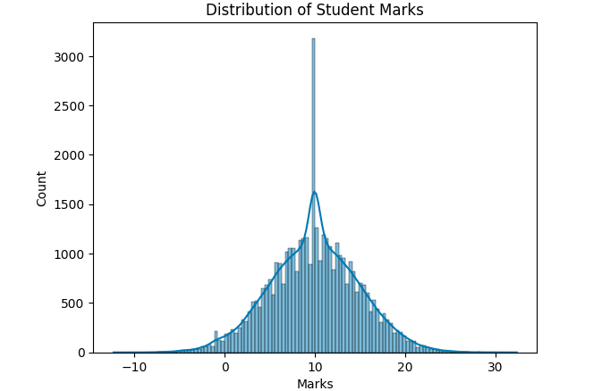

  - This bar chart represents the Distribution of Student Marks in the student performance dataset.
  - It shows that count and marks categories achieved the highest total students.
  - This insight helps identify the most profitable education categories for strategic education focus.

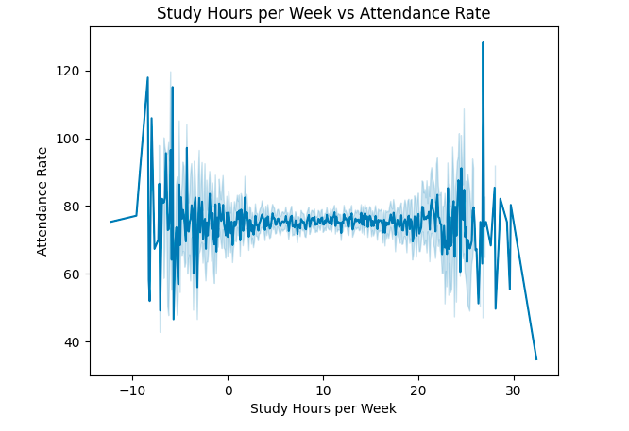
- This line graph illustrates Study Hours per week vs Attendence Rate.
Sales peaked in Attendance Rate 120, indicating a potential seasonal or promotional boost.
- Fluctuations throughout the year highlight opportunities for demand forecasting and inventory planning.

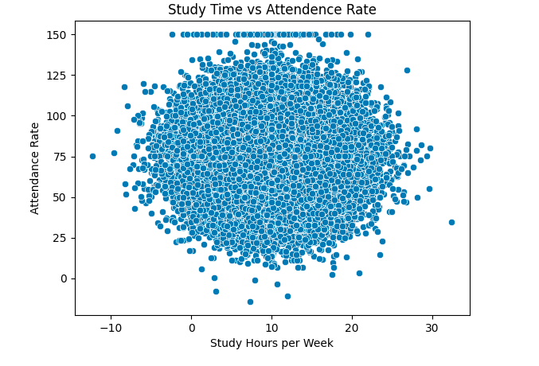
- This scatter plot shows the relationship between Study Time vs Attendence Rate.
- Higher Attendence rate tend to cluster around moderately higher education, indicating a possible positive impact.
- However, the wide spread suggests that factors beyond reviews also influence total students.
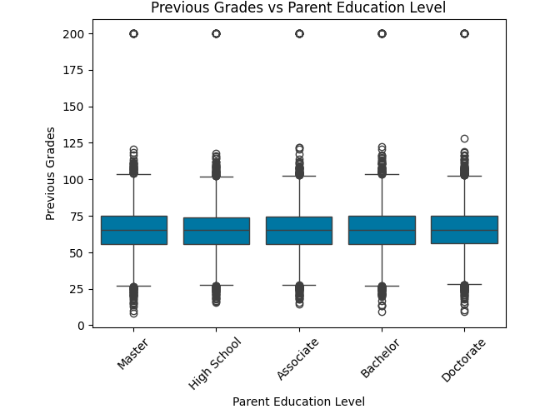

- This box plot displays the previous grades vs parent education level.
- Most categories have a higher education, with medium education.

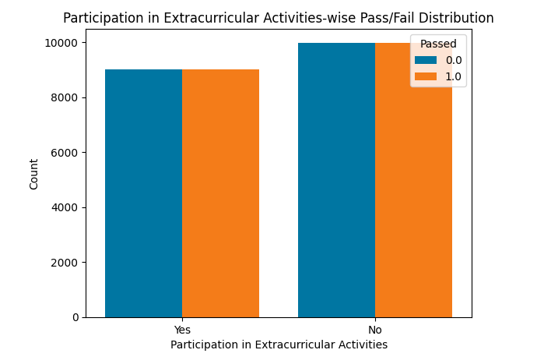

  - The histogram shows a extra curricular activities-wise Pass/Fail Distribution, with no significant concentration in any specific student.
  - Students are evenly passed from low to high percentage, indicating a diverse education strategy across the catalog.
  - This pattern suggests balanced education offerings, useful for targeting various student segments.

USES OF DATA ANALYSIS LIBRARY

Pandas
Pandas served as the core library for data manipulation and analysis in this project. It was used to load and read the student performance dataset in CSV format into Data Frames, making it easy to inspect and explore the structure of the data. With Pandas, operations such as filtering rows, grouping data by product category or month, handling missing values, and calculating aggregate statistics (like total sales, average price, etc.) were efficiently performed. Its high-level data structures helped transform raw data into a clean, structured form suitable for further analysis.

NumPy
NumPy was used primarily for numerical operations and computations within the dataset. It worked behind the scenes with Pandas to provide support for mathematical functions and array operations. NumPy helped calculate statistical measures such as mean, median, standard deviation, and percentage growth in sales. Its integration with Pandas made it easier to handle large numerical datasets and perform fast computations during the exploratory analysis.

Matplotlib
Matplotlib was used to create basic and custom visualizations that communicated key insights from the data. Line charts were developed to show monthly sales trends, bar charts helped in comparing sales across different product categories, and scatter plots were used to explore the relationship between price and sales. The library offered full control over plot formatting, labeling, and styling, making the visual representation of data both informative and customizable.

Seaborn
Seaborn, built on top of Matplotlib, was used for creating more advanced and aesthetically pleasing visualizations. It simplified the process of drawing complex plots such as heatmaps, distribution plots, and box plots. Seaborn was particularly helpful in visualizing correlations between variables, such as review scores and sales volume, or pricing and product success. Its integration with Pandas made it easier to pass data directly from Data Frames into plots without requiring additional formatting

ADVANTAGES

Data-Driven Decision Making
One of the primary advantages of this project is its ability to transform raw e- commerce data into meaningful insights that support data-driven decision- making. By examining sales patterns, customer behavior, and product performance, businesses can move away from intuition-based strategies and adopt an evidence-based approach. This leads to more accurate forecasting and strategic planning.

Improved Understanding of Student Performance
Through detailed exploratory data analysis, the project provides a clearer understanding of how different products and categories perform over time. It reveals which items are consistently top sellers and which underperform, offering businesses the opportunity to refine their product offerings. This understanding extends to seasonal trends, allowing companies to capitalize on peak shopping periods.

Insight into Student Behavior
The analysis uncovers valuable insights into how customer reviews and ratings influence purchasing behavior. Products with higher review scores are often associated with higher sales, suggesting that customer satisfaction is a key driver of success. Understanding these patterns helps businesses focus on quality assurance and improve customer experience to boost brand loyalty.

Effective Communication through Visualization
Another key advantage is the use of visualization tools such as Matplotlib and Seaborn to represent data clearly and intuitively. Complex datasets are

transformed into bar charts, line graphs, and scatter plots, making it easier for stakeholders to interpret trends and insights without deep technical expertise. These visualizations enhance reporting and presentation quality.

Scalability and Reusability
The architecture and code structure used in this project are scalable and reusable, allowing for quick adaptation to larger datasets or different business contexts. Whether applied to another student performance platform or a new set of products, the same framework can be reused with minimal modification. This flexibility makes the project valuable for long-term analytical needs.

Cost and Time Efficiency
Automating the data cleaning, transformation, and analysis processes using Python libraries significantly reduces the time and effort required to conduct the analysis manually. It also minimizes human error, ensuring more accurate and consistent results. As a result, the project not only saves resources but also increases the overall efficiency of business operations.

Strategic Advantage in a Competitive Market
Ultimately, the ability to derive insights from data gives businesses a strategic edge. By identifying emerging trends and adapting quickly, companies can stay ahead of competitors. The insights gained from this analysis support proactive strategy development, enabling businesses to respond to market changes more effective.

CONCLUSION
This project, “Student Performance Prediction: An Exploratory Data Analysis Approach,” successfully illustrates the critical role that data analysis plays in today’s student performance industry. By applying Exploratory Data Analysis (EDA) techniques using Python’s powerful libraries—Pandas, NumPy, Matplotlib, and Seaborn—we uncovered a wide range of patterns and trends from a dataset of 40000 records across 12 types of sales.
The analysis revealed several key business insights. For instance, sales patterns showed clear seasonality, with noticeable spikes during certain months, indicating the need for strategic planning around marketing and inventory during peak periods. Category-wise analysis helped identify high-performing student groups, while review score evaluations underscored the strong correlation between customer satisfaction and product success.
One of the major strengths of this project lies in its ability to convert raw, unstructured data into meaningful insights through clean, readable code and intuitive visualizations. The visual tools used not only simplified complex data relationships but also made the analysis accessible to non-technical stakeholders, enhancing its practical value in a business context.
In summary, this project demonstrates how businesses can harness the potential of data to gain a competitive advantage. By identifying what drives customer behavior, product success, and revenue growth, companies can make more informed, timely, and strategic decisions. As student performance continues to grow and evolve, the ability to extract, interpret, and act on data insights will remain a key differentiator for successful organizations.

Reference Websites or Links

The information for this documentation has been drawn from the following sources:

Student performance prediction

Student Performance Prediction. An Exploratory Data Analysis &… | by Raimi Azeez Babatunde | Medium

Student Performance and Engagement Prediction in eLearning datasets | IEEE DataPort

